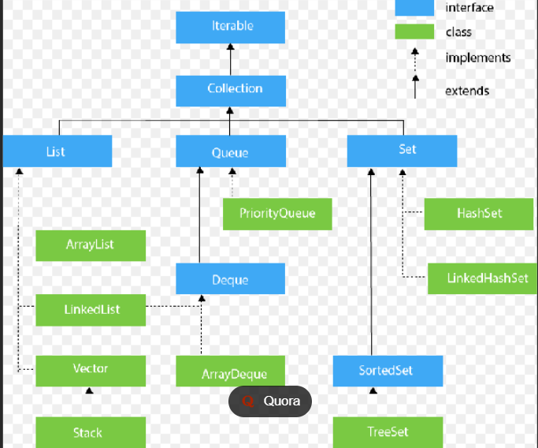

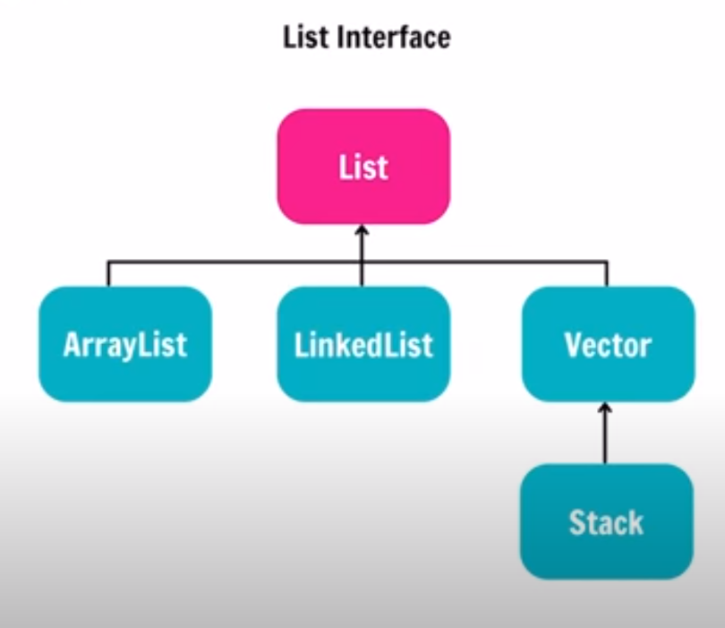

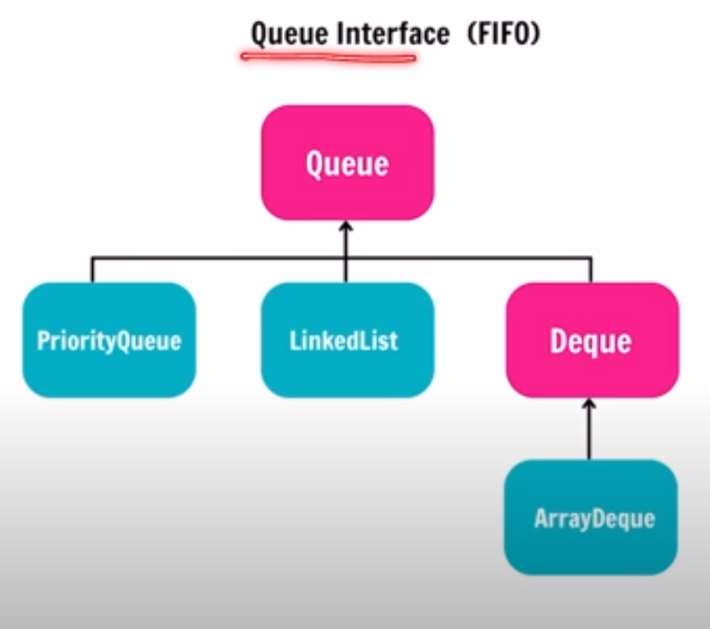

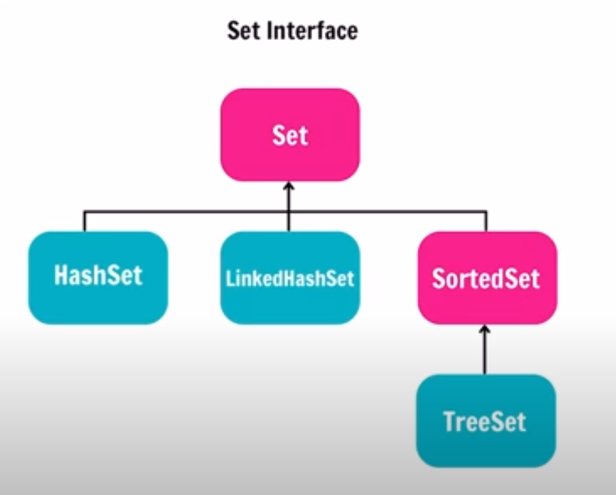

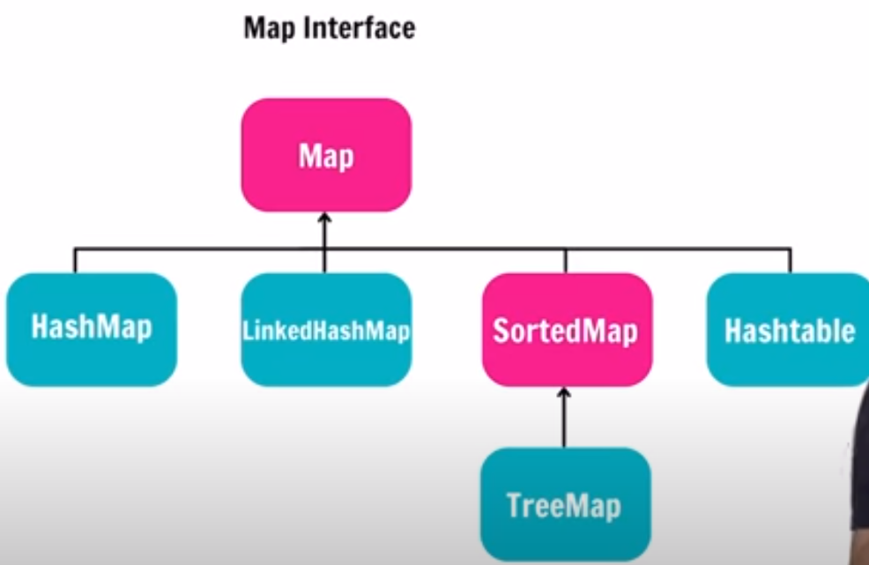

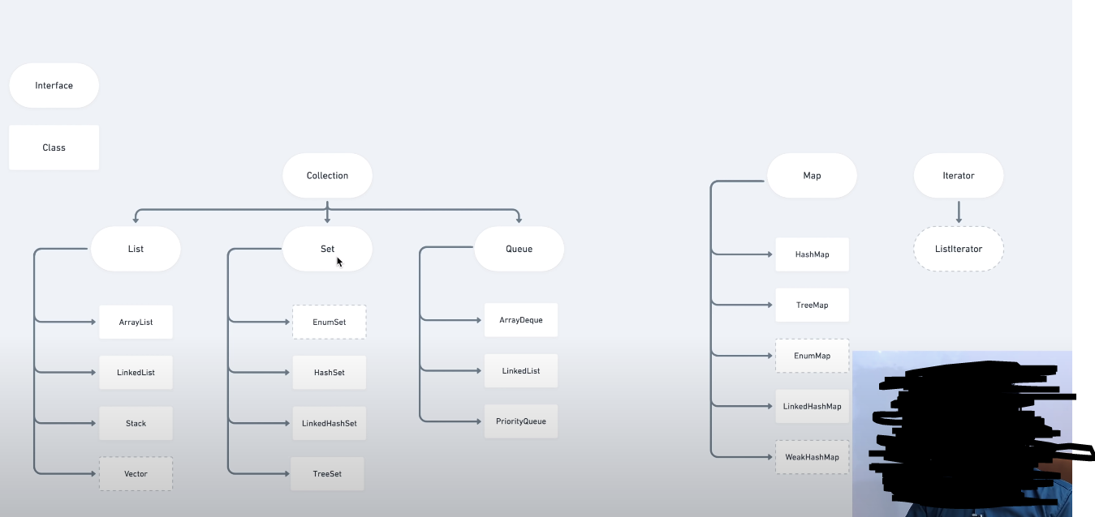

Arrays

* **Set, Check** element at a particular index: **O(1)**
* **Searching**: **O(n)** if array is unsorted and **O(log n)** if array is sorted and something like a binary search is used,
* As pointed out by [Aivean](https://stackoverflow.com/users/1349366/aivean), there is no Delete operation available on Arrays. We can symbolically delete an element by setting it to some specific value, e.g. -1, 0, etc. depending on our requirements
* Similarly, Insert for arrays is basically Set as mentioned in the beginning

ArrayList:

* **Add**: **Amortized O(1)**
* **Remove**: **O(n)**
* **Contains**: **O(n)**
* **Size**: **O(1)**

Linked List:

* **Inserting**: **O(1)**, if done at the head, **O(n)** if anywhere else since we have to reach that position by traversing the linkedlist linearly.
* **Deleting**: **O(1)**, if done at the head, **O(n)** if anywhere else since we have to reach that position by traversing the linkedlist linearly.
* **Searching**: **O(n)**

Doubly-Linked List:

* **Inserting**: **O(1)**, if done at the head or tail, **O(n)** if anywhere else since we have to reach that position by traversing the linkedlist linearly.
* **Deleting**: **O(1)**, if done at the head or tail, **O(n)** if anywhere else since we have to reach that position by traversing the linkedlist linearly.
* **Searching**: **O(n)**

Stack:

* **Push**: **O(1)**
* **Pop**: **O(1)**
* **Top**: **O(1)**
* **Search** (Something like lookup, as a special operation): **O(n)** (I guess so)

Queue/Deque/Circular Queue:

* **Insert**: **O(1)**
* **Remove**: **O(1)**
* **Size**: **O(1)**

Binary Search Tree:

* **Insert, delete and search**: Average case: **O(log n)**, Worst Case: **O(n)**

Red-Black Tree:

* **Insert, delete and search**: Average case: **O(log n)**, Worst Case: **O(log n)**

Heap/PriorityQueue (min/max):

* **Find Min/Find Max**: **O(1)**
* **Insert**: **O(log n)**
* **Delete Min/Delete Max**: **O(log n)**
* **Extract Min/Extract Max**: **O(log n)**
* **Lookup, Delete** (if at all provided): **O(n)**, we will have to scan all the elements as they are not ordered like BST

HashMap/Hashtable/HashSet:

* **Insert/Delete**: **O(1)** amortized
* **Re-size/hash**: **O(n)**
* **Contains**: **O(1)**

**STACK**

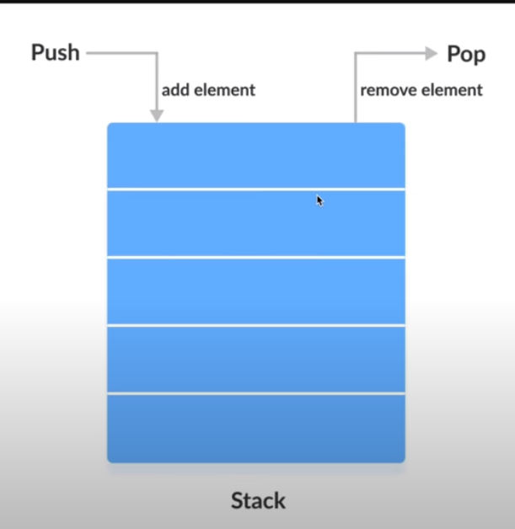

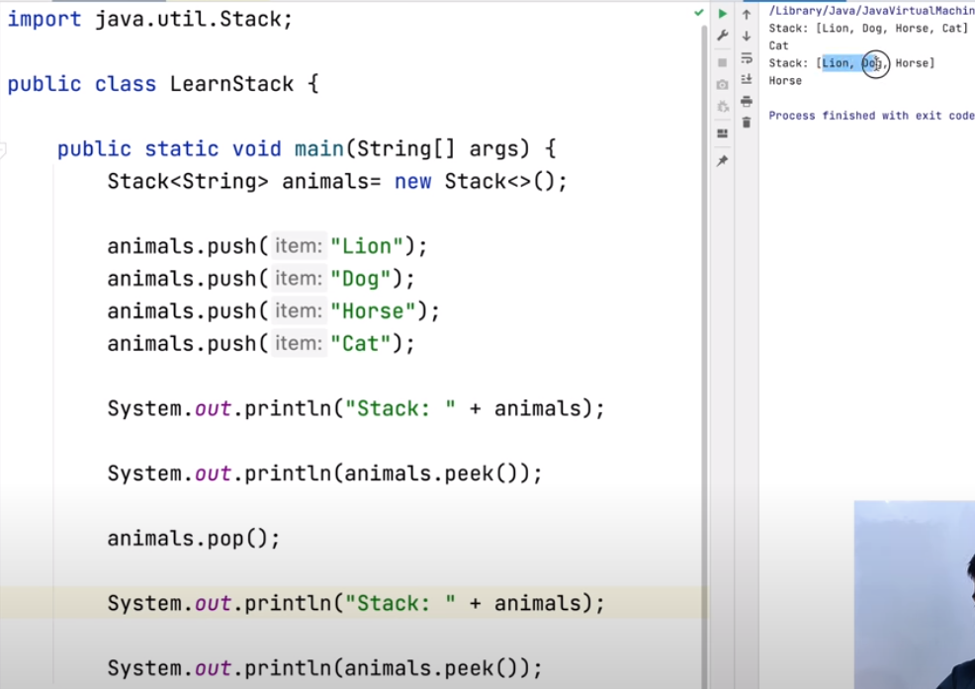

**QUEUE(LINKEDLIST)**

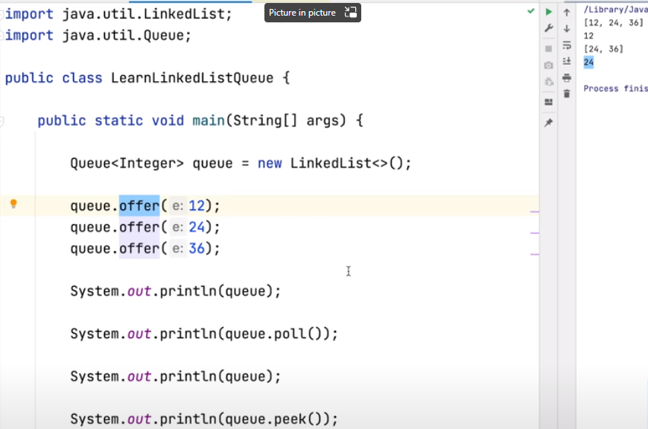

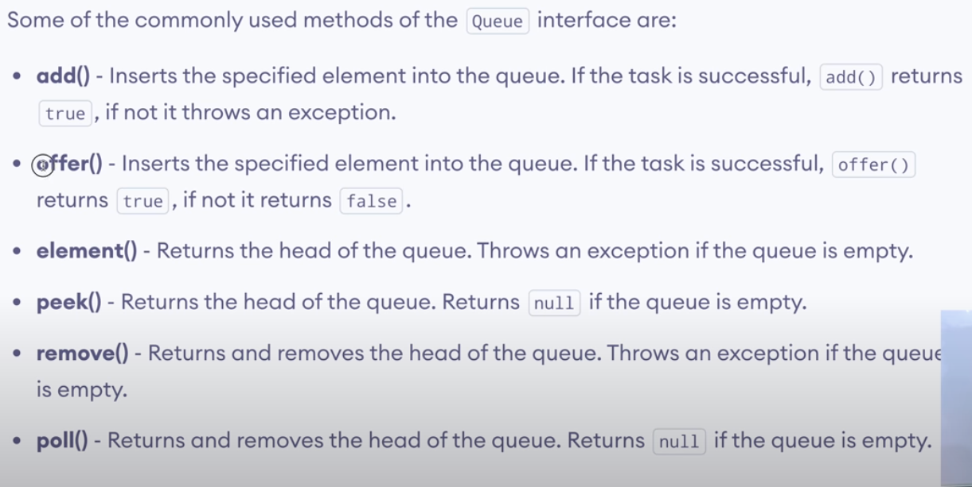

**QUEUE(PRIORITYQUEUE/MIN HEAP)**

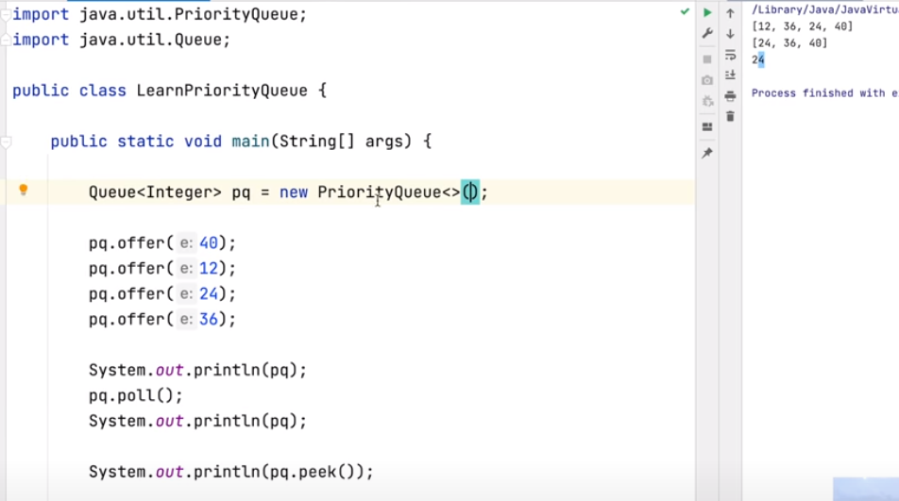

**QUEUE(PRIORITYQUEUE/MAX HEAP)**

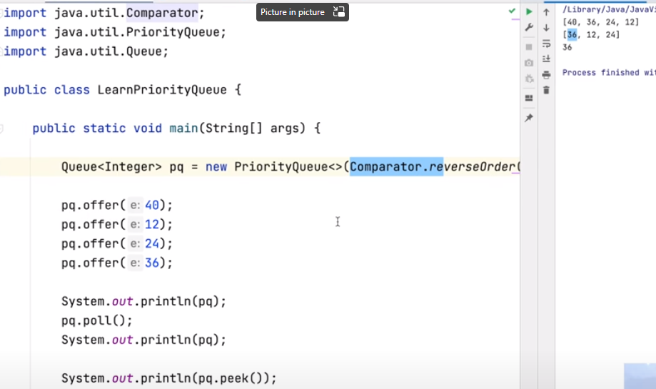

**ARRAYDEQUE (Pronounced as ARRAYDECK)**

In this Data structure we can push,poll,peek from front side as well as back side.

Offer and OfferLast works the same as in adding the element at the end of the queue

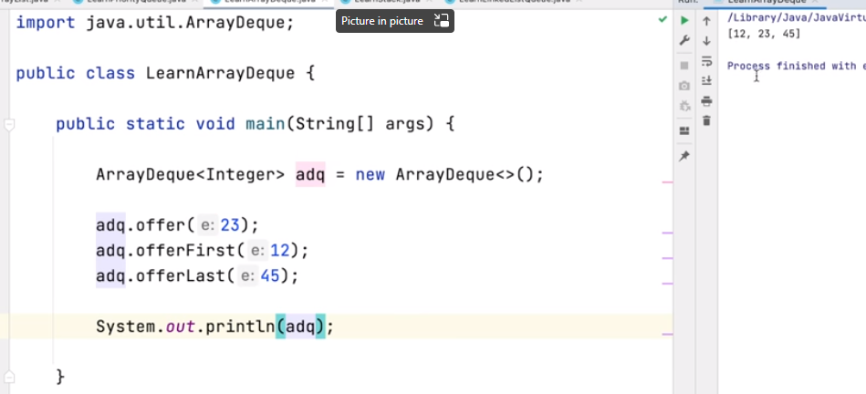

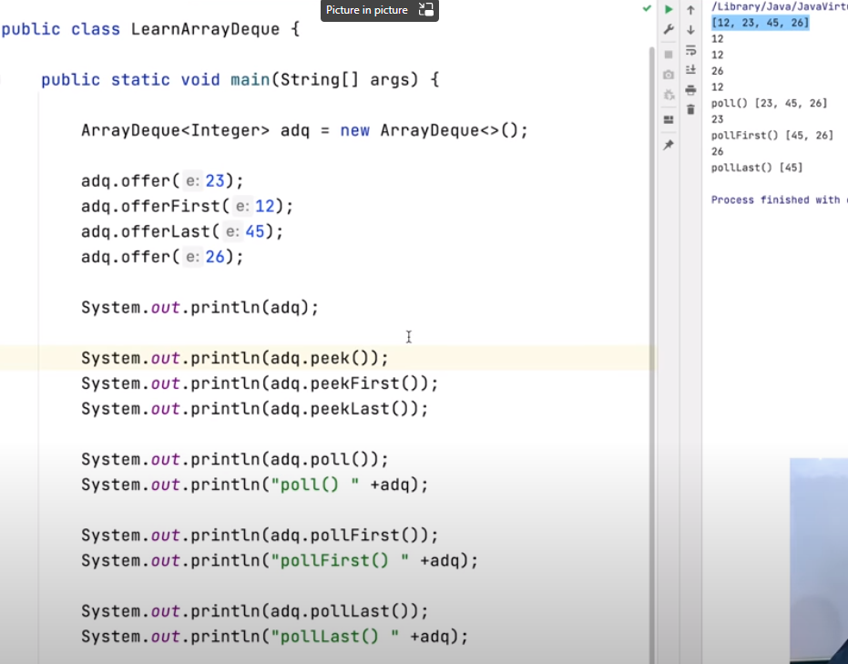

**SET (hashset)**

**Order not maintained**

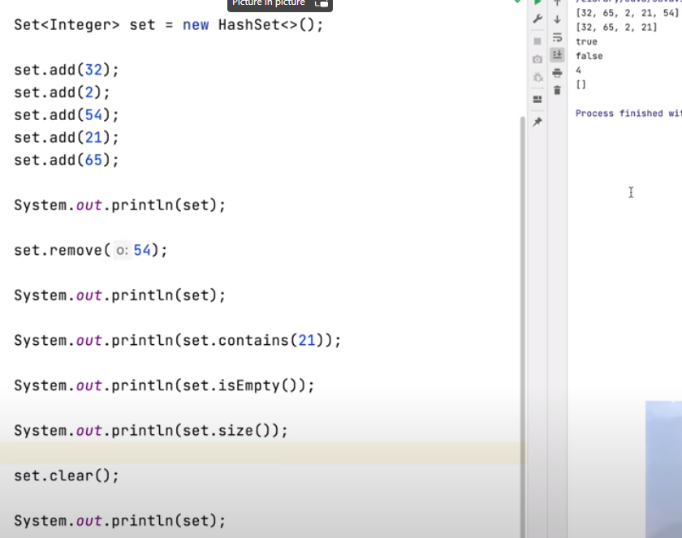

**SET (linkedhashset)**

**Order maintained**

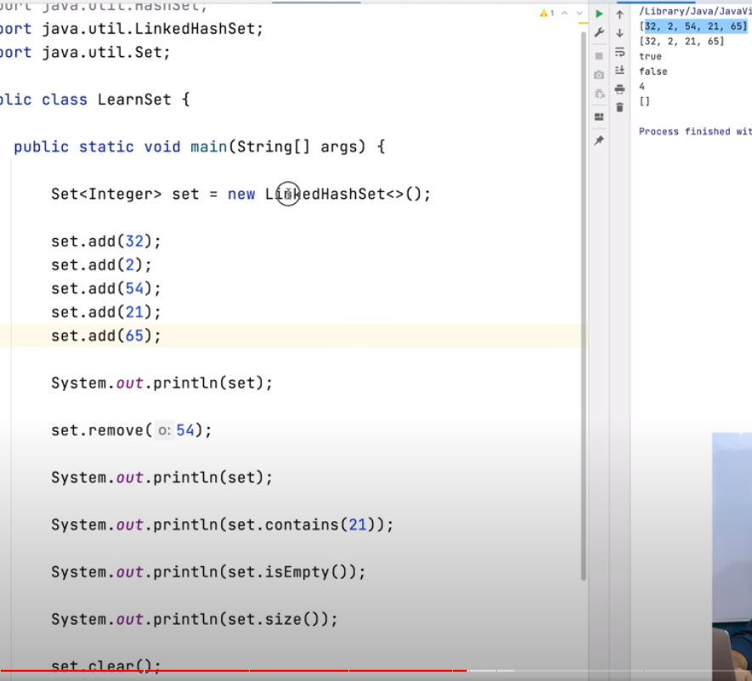

**SET (TreeSet)**

**Sorted order (Binary search tree)**

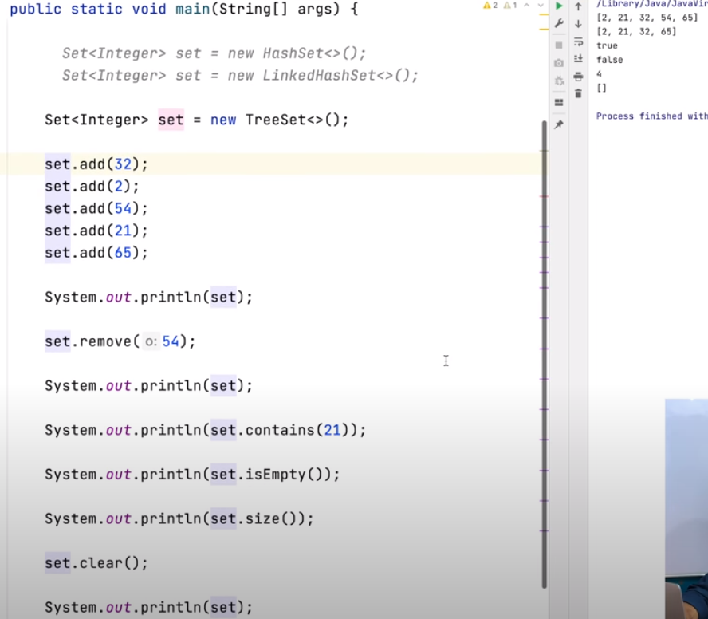

**HashMAP**

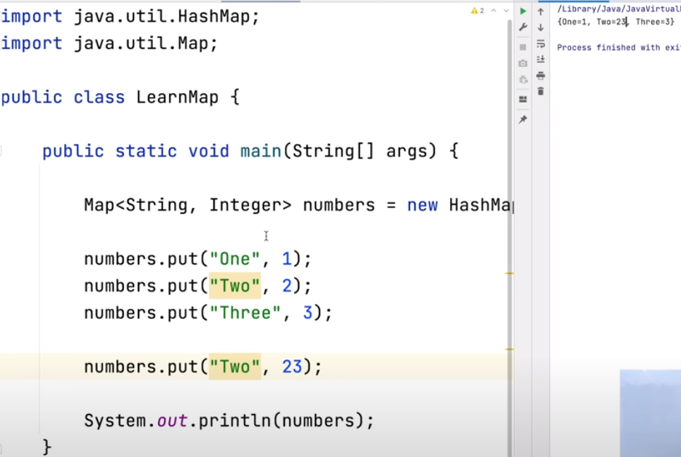

**containsKey if condition can be replaced by putIfAbsent method**

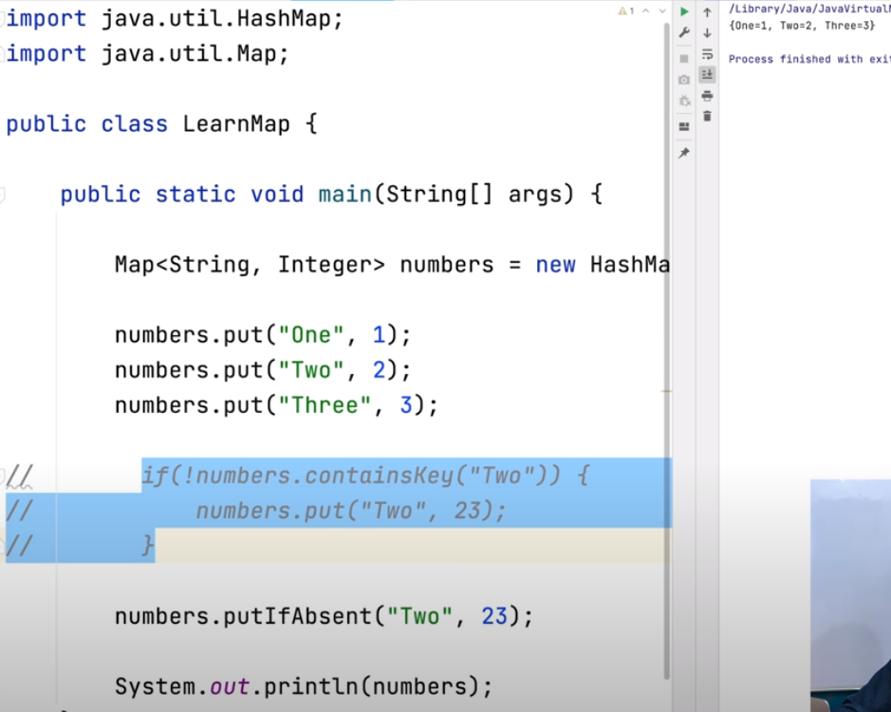

**ARRAYS CLASS UTILS**

**BINARYSEARCH**

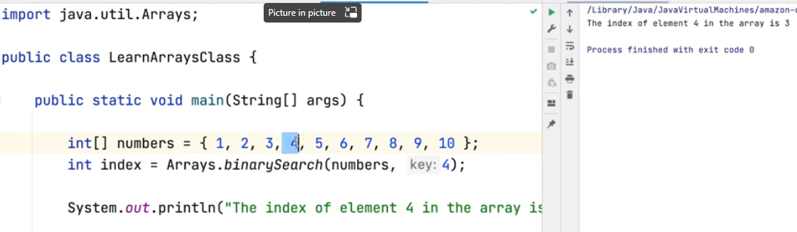

**SORT**

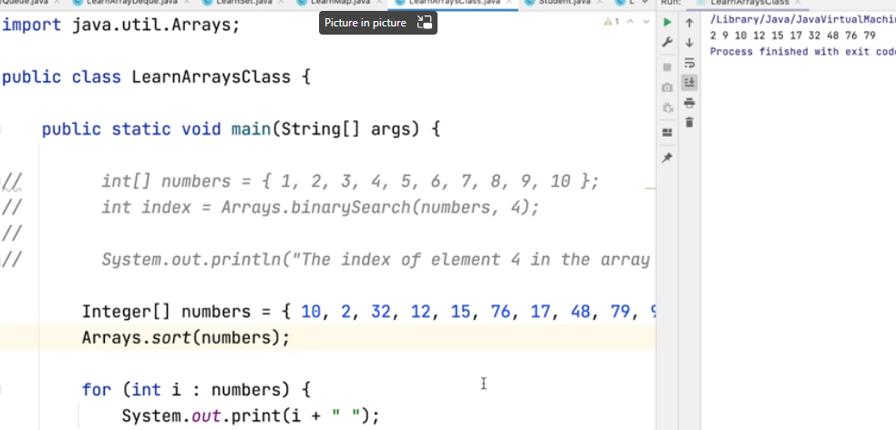

**FILL**

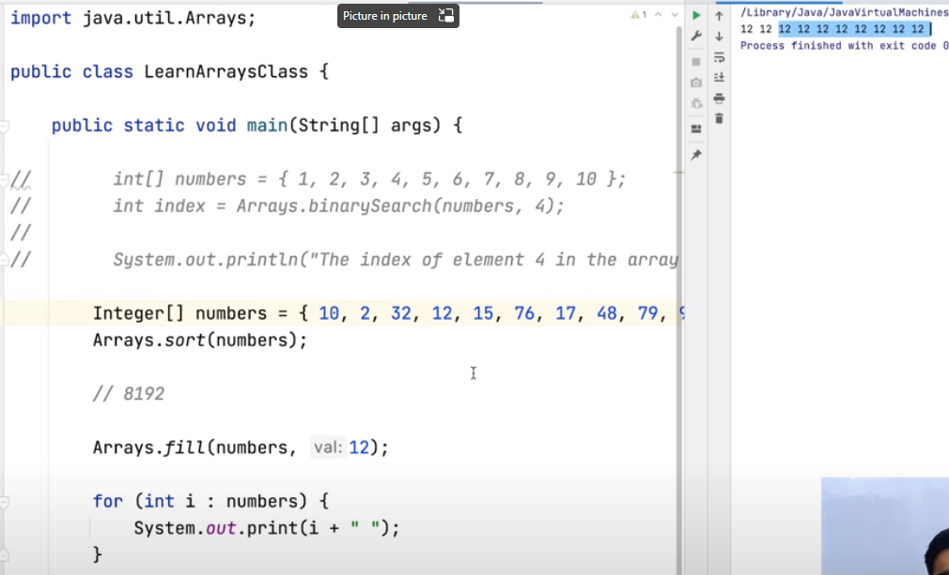

**COLLECTIONS UTIL CLASS**

**Find min , max or frequency**

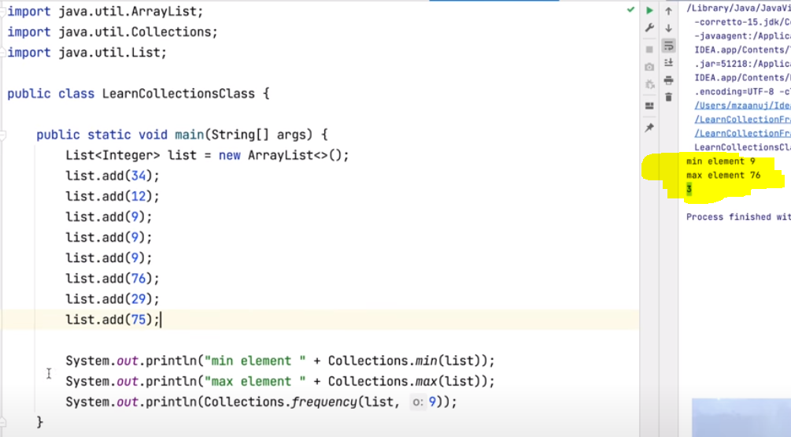

**Sort in ascending order**

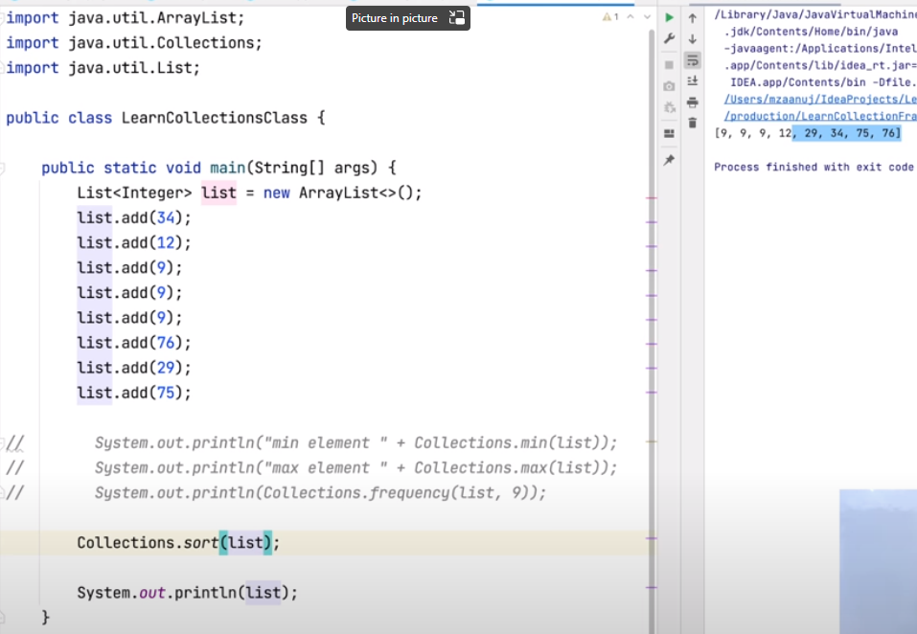

**Sort in descending order**

